Olton and West Warwickshire Organisation Structure

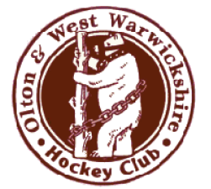
Olton and West Warwickshire Hockey Club
Management Committee

Chair
Vice Chair
Junior Coordinator
Treasurer
Secretary
Membership Secretary
Development Officer
Management and Grounds
Welfare Officer

Men’s Playing
Committee
Chair
Captains
Head Coach
Junior Co-ordinator
Chair of Selectors
Fixture and Umpire Secretary
Ladies Playing
Committee
Chair
Captains
Coaches
Junior Co-ordinator
Chair of Selectors
Fixture Secretary
Junior Representative
Junior Section

Chair
Head Junior coach
Assistant coaches
Membership Secretary
First Aider
Welfare Officer
Team Managers

